**PSUC Lab Assignment**

**Lab 5:**

**Q1**) Find the largest and smallest element in a 1D array.

**Code**:

#include<stdio.h>

void main()

{

int a[10],n,i,j,temp;

char choice;

printf("Enter the number of elements\n");

scanf("%d",&n);

printf("Enter the elements now\n");

for(i=0;i<n;i++)

scanf("%d",&a[i]);

printf("The array elements are\n");

for(i=0;i<n;i++)

printf("%d\t",a[i]);

printf("\n");

for(i=0;i<n-1;i++)

{

for(j=0;j<n-1;j++)

{

if(a[j]>a[j+1])

{

temp=a[j];

a[j]=a[j+1];

a[j+1]=temp;

}

}

}

printf("the largest number is: %d\n",a[i]);

printf("the smallest number is: %d\n",a[0]);

printf("My name is Saksham");

}

**Output**:

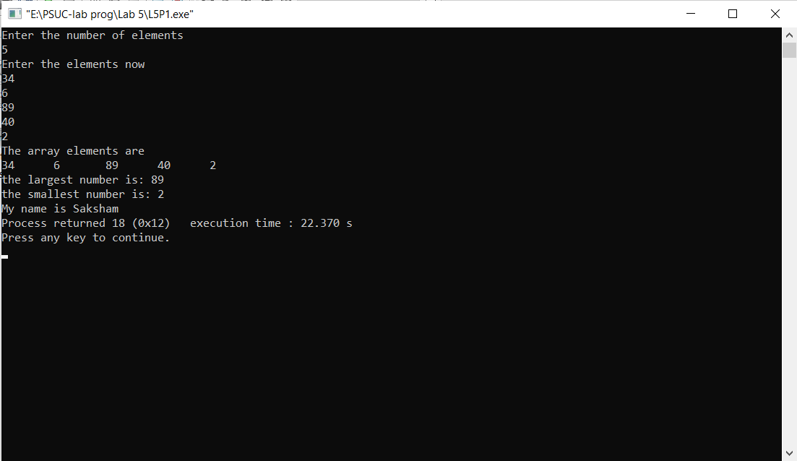

**Q2**) Print all the prime numbers in a given 1D array.

**Code**:

#include<stdio.h>

void main()

{

int a[10],n,i,j,count;

printf("Enter the number of elements into the array\n");

scanf("%d",&n);

printf("Enter the elements now\n");

for(i=0;i<n;i++)

scanf("%d",&a[i]);

printf("entered array is \n");

for(i=0;i<n;i++)

printf("%d\n",a[i]);

for(i=0;i<n;i++)

{

count = 0;

for (j=1;j<=a[i];j++)

{

if(a[i]%j==0)

count++;

}

if (count == 2)

printf("%d is a prime number\n",a[i]);

else

printf("%d is not a prime\n",a[i]);

}

printf("My name is Saksham\n");

}

**Output**:

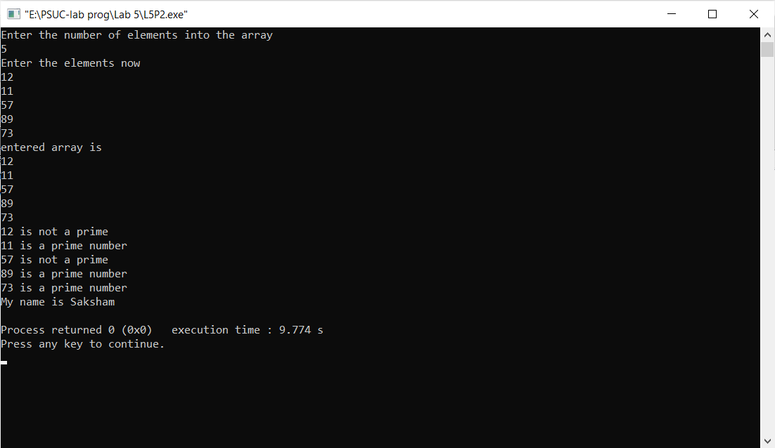

**Q3**) Bubble sort the elements input in the array in ascending and descending order

**Code**:

#include<stdio.h>

void main()

{

int a[10],n,i,j,temp;

char choice;

printf("Enter the number of elements\n");

scanf("%d",&n);

printf("Enter the elements now\n");

for(i=0;i<n;i++)

scanf("%d",&a[i]);

printf("The array elements are\n");

for(i=0;i<n;i++)

printf("%d\t",a[i]);

fflush(stdin);

printf("\nenter 'a'for sorting in ascending order and 'd' for sorting in descending order: \t");

scanf("%c",&choice);

switch(choice)

{

case 'a': for(i=0;i<n-1;i++)

{

for(j=0;j<n-1;j++)

{

if(a[j]>a[j+1])

{

temp =a[j];

a[j]=a[j+1];

a[j+1]=temp;

}

}

}

break;

case'd': for(i=0;i<n-1;i++)

{

for(j=0;j<n-1;j++)

{

if(a[j]<a[j+1])

{

temp =a[j];

a[j]=a[j+1];

a[j+1]=temp;

}

}

}

break;

default: printf("invalid choice\n");

}

printf("the sorted array is: \n");

for(i=0;i<n;i++)

printf("%d\n",a[i]);

printf("My name is Saksham");

}

**Output**:

Ascending Order:

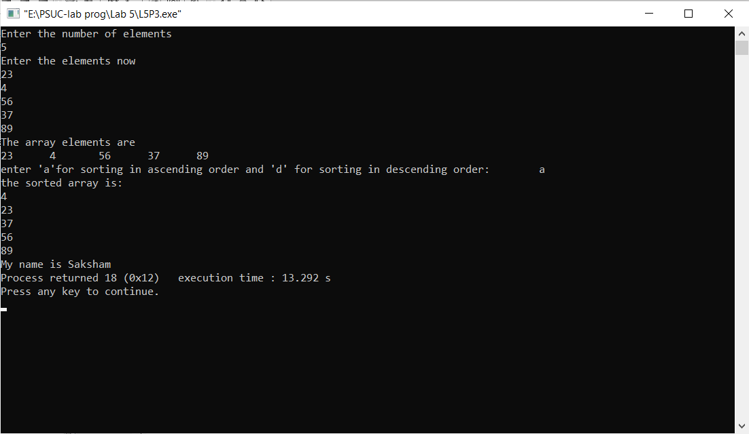

Descending Order:

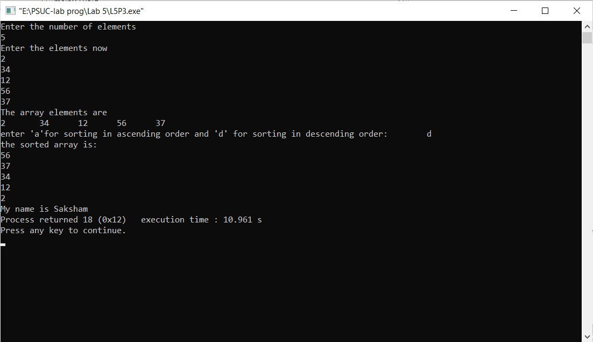

**Q4**) Insert an element into a 1D array by getting an element and the position from the user.

**Code**:

#include <stdio.h>

int main()

{

int array[100], position, c, n, value;

printf("Enter number of elements in array\n");

scanf("%d", &n);

printf("Enter %d elements\n", n);

for (c = 0; c < n; c++)

scanf("%d", &array[c]);

printf("Enter the location where you wish to insert an element\n");

scanf("%d", &position);

printf("Enter the value to insert\n");

scanf("%d", &value);

for (c = n - 1; c >= position - 1; c--)

array[c+1] = array[c];

array[position-1] = value;

printf("Resultant array is\n");

for (c = 0; c <= n; c++)

printf("%d\t", array[c]);

printf("\nMy name is Saksham");

return 0;

}

**Output**:

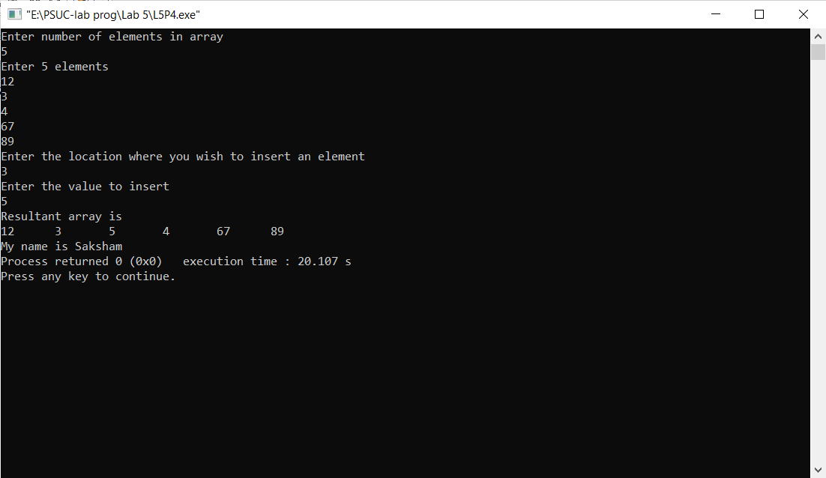

**Q5**) Search the position of the number that is entered by the user and delete that number from the array and display the resultant array elements.

**Code**:

#include<stdio.h>

int main(){

int a[10],n,pos=0,x,temp;

printf("Enter the no of elements:\n");

scanf("%d",&n);

printf("Enter the elements:\n");

for(int i=0 ; i<n ; i++){

scanf("%d",&a[i]);

}

printf("Enter the no to be deleted:");

scanf("%d",&x);

for (int i=0 ; i<n ; i++){

if(a[i]==x){

pos=i;

}

}

for (int i=pos ; i<n-1 ; i++){

a[i]=a[i+1];

}

printf("The new array is :\n");

for(int i=0 ; i<n-1 ; i++){

printf("%d\t",a[i]);

}

printf("\nMy name is Saksham");

return 0;

}

**Output**:

